2013 Melbourne Hamfest
Lodging Information

Prices are starting or event prices and are approximant
Mention the Melbourne Hamfest – Many prices listed are discounted. Taxes and fees will be extra.

DAYS INN
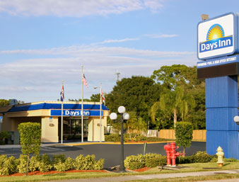

Room Rate : $55.00

Breakfast, WIFI

1515 S. Harbor City Blvd (US1)

Melbourne, FL 32901

321-723-4430

***

Hampton Inn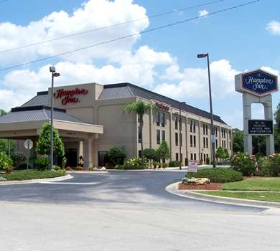
Room Rate : $65.00

Breakfast, WIFI

194 Dike Road

Melbourne, FL 32904
321-956-6200

6.2 miles to Hamfest

***

Holiday Inn Express
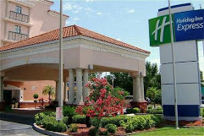
Room Rate : $79.00
Breakfast, WIFI
4510 W. New Haven Ave.
Melbourne, FL 32904

321-724-2050

5.5 miles to Hamfest

***

Budget Inn
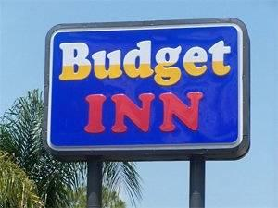
Room Rate : $43.00

Breakfast, WIFI

4505 W. New Haven Ave.

Melbourne, FL 32904

321-724-5450

5.5 miles to Hamfest

***

