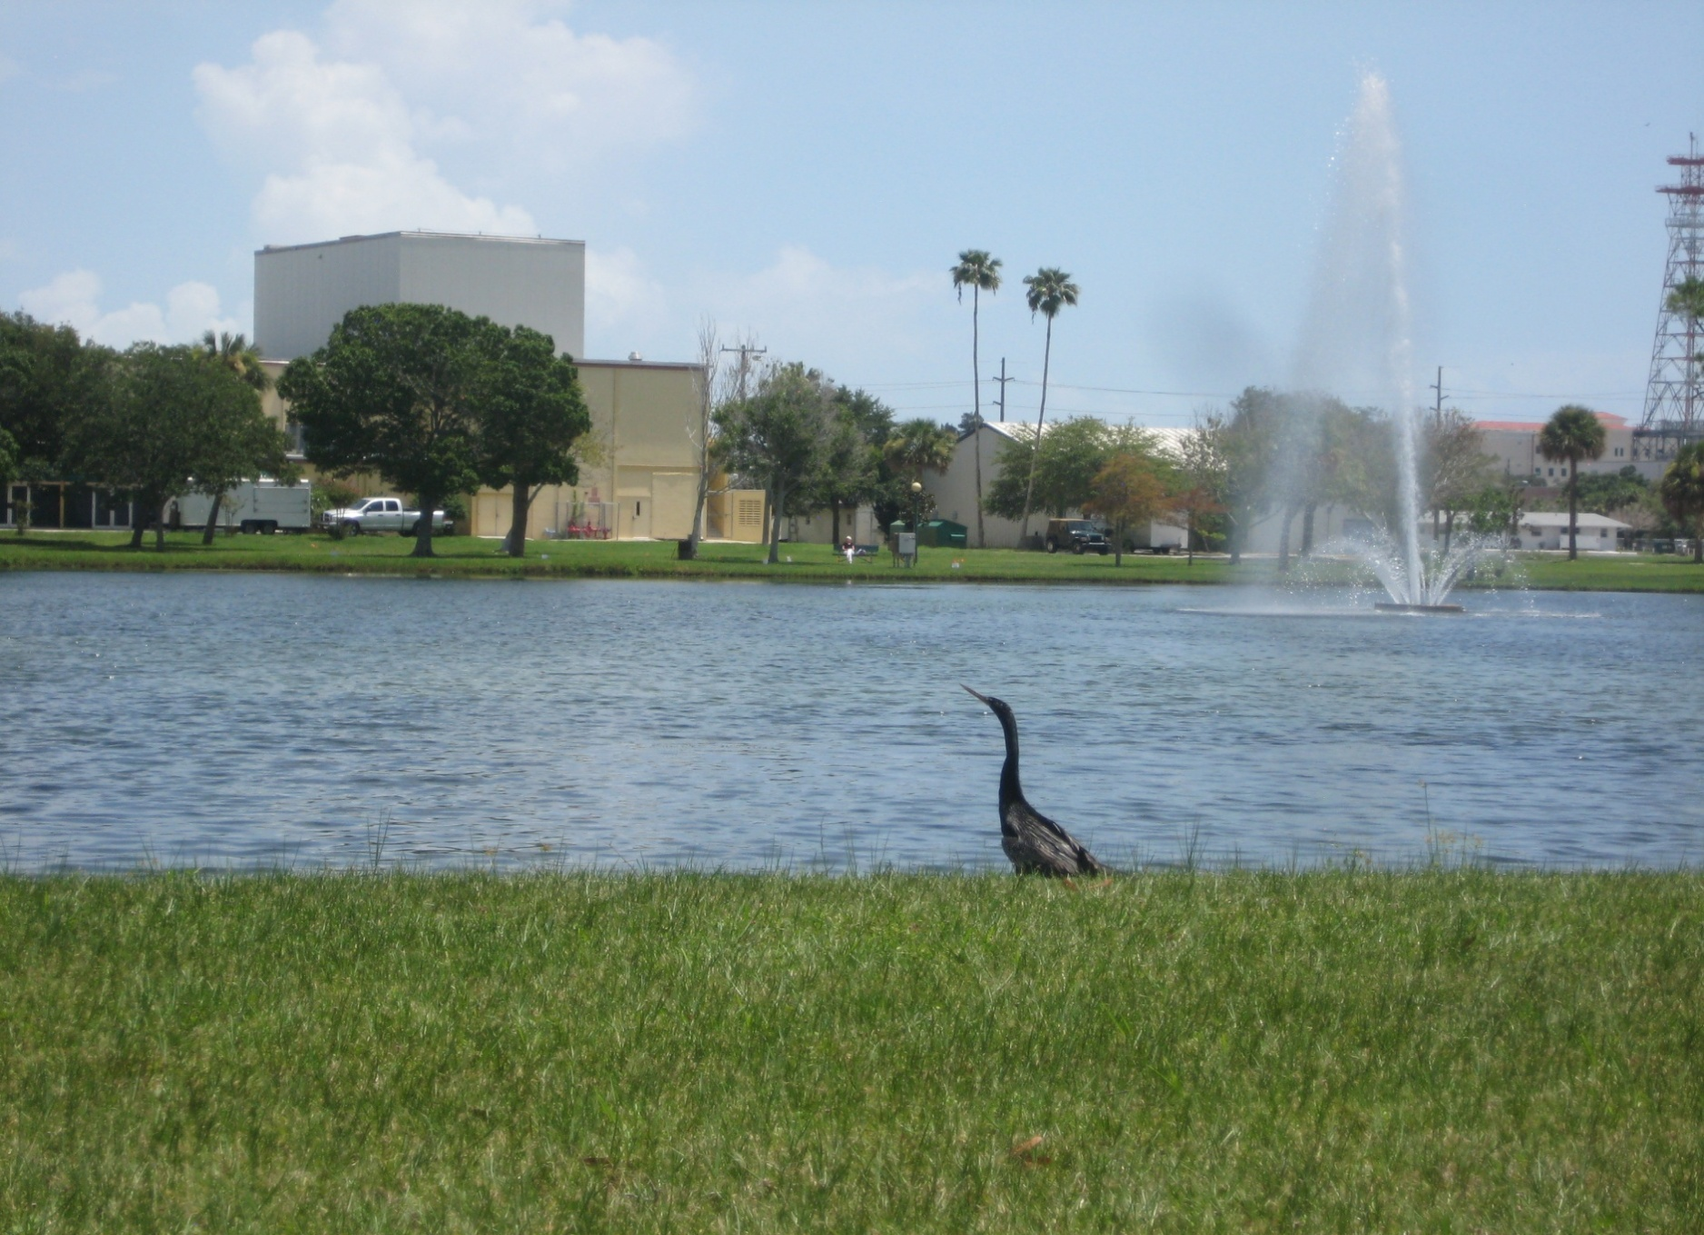
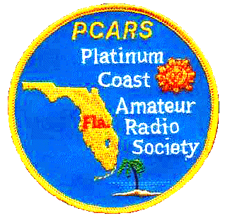

Platinum Coast
Amateur Radio Society
(PCARS)

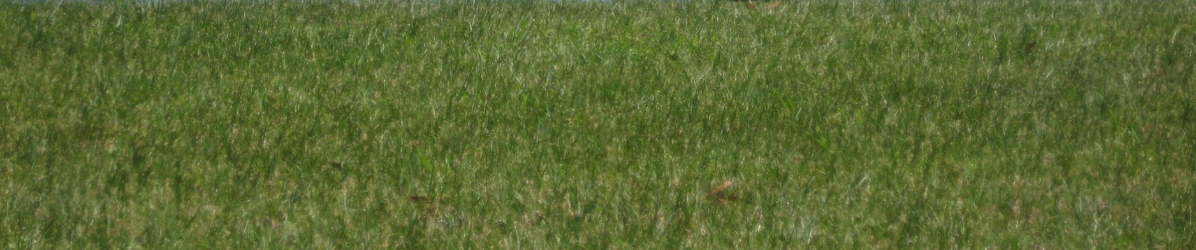
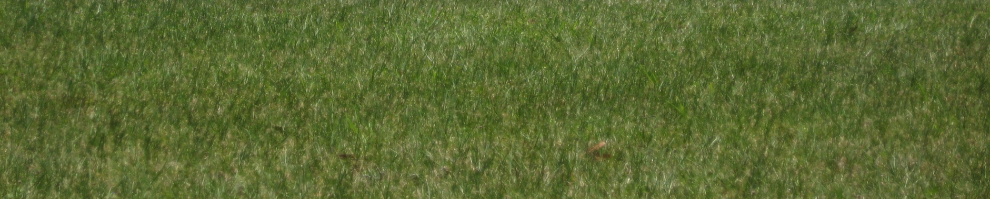
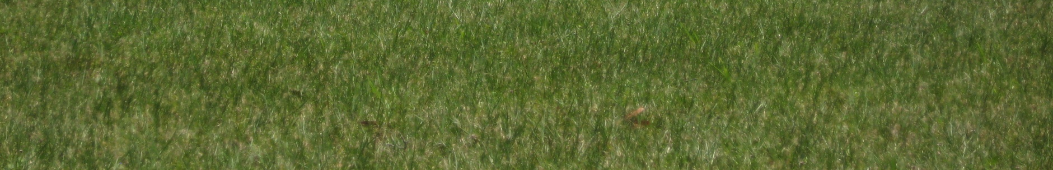
50th Annual Melbourne Hamfest &
2015 ARRL Florida State Convention
October 9 & 10, 2015

Cordially Invites You, Your Friends and Family
to the
Photo by AK4R

Platinum Coast Amateur Radio Society (PCARS)
Melbourne Hamfest
Key Venue and Contact Information
Note: this is a Friday and Saturday event

When: Friday: October 9th 2:30PM-7PM
Saturday: October 10th 9AM-4PM

Where: Melbourne Auditorium
625 E. Hibiscus Boulevard, Melbourne, FL 32901
(next to beautiful Wells Park)

Entrance: Tickets: $6.00 before Sept. 30 2015 $7.00 afterwards and at door

Talk in: W4MLB,146.25/146.85
(Open repeater, no PL)

Tailgating: Great outside swap area:
$10.00 per designated parking
space, Opens 10AM Friday
Limited parking of large vehicles
in Tailgate area. $2.00/linear ft.
Setup: Early Commercial Booths Setup and those with 8 or more Swap Tables:
Friday - 10AM-2PM
Those with 1-7 Swap Tables Setup:
Friday - Noon-2PM
All: Saturday - 7-9AM

Chairman: Eric Smitt, K9ES; 321-698-8307

Booths/: oldBill, N4LXL bbpinkerton@gmail.com
Tables

Email: hamfest2015@pcars.org

Website: www.pcars.org
see for additional vendor booth, swap table, tailgate area layouts, hotel & program details

Mail: PCARS Melbourne Hamfest
P.O. Box 1004
Melbourne, FL 32902-1004

- We have expanded the Handicap parking area
- We provide non-tailgating parking area for Motorhomes behind the auditorium Friday Night only.
- We provide free Motorcart service to and from the parking area to the main entrance for those needing a little help.
- We will try to provide tailgate parking of Motorhomes that plan to tailgate (Space is limited and not guaranteed)

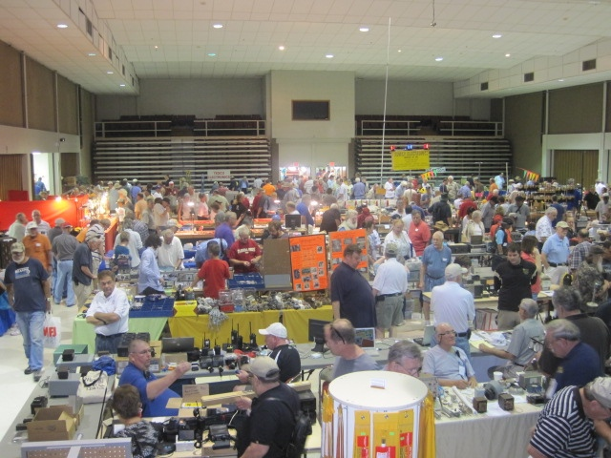
Platinum Coast Amateur Radio Society (PCARS)
Melbourne Hamfest
Exhibit / Trading Area inside Auditorium with
3 Large rooms of Commercial and Swap Tables

Photo by AF4Z
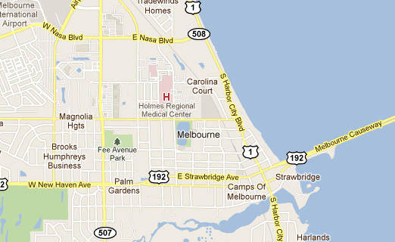
Hamfest
Platinum Coast Amateur Radio Society
(PCARS)
Melbourne Hamfest
Location Map

Melbourne Auditorium, 645 E Hibiscus Blvd, Melbourne, FL 32901

he

E.Hibiscus Ave.
Melbourne Auditorium

from Google Maps (annotated)
Platinum Coast Amateur Radio Society (PCARS)
Melbourne Hamfest
Past Prize Donors…Thank You!
he

Hamfest Prize Donors

>>> INCOMPLETE <<<

We will post the donors of the 2015 Hamfest prizes on our website as soon as they are known. Visit the website often.
Order your advanced tickets, Commercial Tables and Swap Tables using the Tickets and Vendor Reservation Request on the following page. Last year we had a sellout on swap tables and expect to have them sold out again so get yours soon.
This year, we are also implementing an on-line registration form for attendees to alternatively register for tickets and tables via the internet. If you wish, you may register and/or order tickets using this Paypal and Credit Card Payment service. The link to register on-line is:
https://secure.billmyway.com/pcars
If you are requesting specific tables, then use the PCARS website Auditorium Layout page to select. Note that we cannot accept “request” assignments after August 22nd.
Tickets and Vendor Reservation Request
NAME____________________________________________________________________
STREET__________________________________________________________________
CITY______________________________________STATE____________ZIP___________
Contact Person_________________________________
Phone________________________ Email_______________________________________

Commercial Booths: Commercial booths normally include a wall, table skirts and electric outlets. Most commercial tables are eight feet long. When reserving commercial booths or tables, please refer to the floor plan and indicate your preference. In the booths with support tables at the rear of the booth, the vendor pays only for the front and end-cap tables. With commercial booths, the purchase of entry tickets for door prizes and grand prizes is optional. Booth tables are priced starting at $80.00 per front table. Price depends on booth size and location. Contact us for details about the pricing of a booth. We will try to work with you to package what you need at an affordable price.

Commercial Booth per Quote $_____________ Booth Numbers __________________

Commercial Booth Vendor Set-Up Passes for booth (free) Quantity ____________

Entry/Door Prize and Grand Prize tickets (optional) @ $6.00 each QTY____ $________

Swap Tables: Some vendors prefer to order a number of swap tables in-lieu-of commercial booths.
These six foot tables include all the numbered tables in the auditorium. Commercial vendor requests
for more than four tables will be given priority on location and availability of power in the floor area of
the tables. Swap tables require the purchase of Entry/Door Prize and Grand prize tickets.

Swap Tables, $20.00 Each /Table Numbers __________ QTY. _______ $___________

Entry and prize tickets (and setup passes) @ $6.00 each QTY._____ $___________
Make Checks Payable to PCARS Melbourne Hamfest TOTAL $______________________
Tailgate Area: The outside tailgate spaces are all designated. They are $10.00 per designated parking space or $2.00/linear foot. These spaces are first come, first served Friday.
Special requests by vendors wanting multiple spaces or larger areas will be accommodated
if possible. Contact us if you have a special request. Hamfest2015@pcars.org

Mail to:
PCARS Melbourne Hamfest
P.O. Box 1004
Melbourne, FL 32902-1004

