Friday: 2:30 PM - 7PM Saturday: 9AM - 4PM
Setup: Fri, Oct 9th - 10:00AM to 2:30PM, Sat, Oct. 10th 7:00AM to 9:00AM
Admission Tickets $6 until Sept. 30, $7 after. Age 12 and Under Free.

• GREAT Outside TAILGATE Area
$10.00 per designated parking space - first come, first served after 12:00 Noon Friday. Tailgate areas not designated as regular parking are $2.00/linear foot; these areas will only be assigned by special request. Come early - open at 6:00AM on Saturday! Admission tickets required in tailgate area.

Registration Information: Tickets purchased before Sept. 30 are $6.00 and $7.00 after Sept. 30, 2015. Tickets are required everywhere on Auditorium property-inside and outside. Age 12 and under is free. Requests must include Self Addressed Stamped Envelope for advance tickets or pick-up at the door.

• Talk in: W4MLB on 146.25/146.85 repeater - NO PL Tone

• Location: Melbourne Auditorium, 625 E. Hibiscus Blvd, Melbourne, Florida 32901

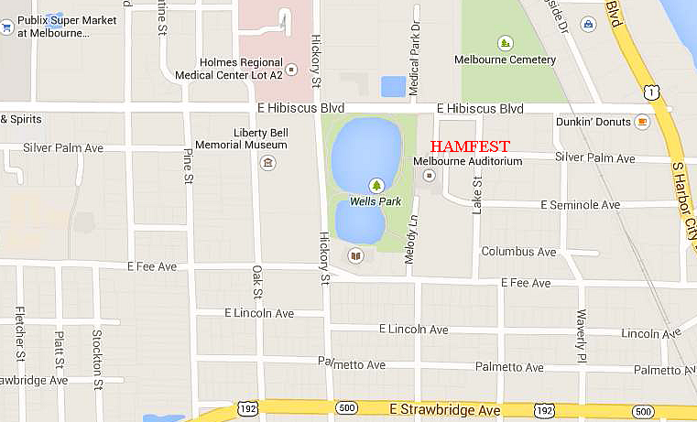

• Plenty of Inside commercial booths and swap tables

• Consignment table will be available

• Amateur Radio Exams will be given on site

• Excellent FORUMS and MEETINGS

• Main Prizes and Hourly Door Prizes will be awarded

• ARES Badging - will be available all day Saturday
E-Mail your information requests to hamfest2015@pcars.org

US Mail: PCARS Melbourne Hamfest
P.O. Box 1004
Melbourne, FL 32902-1004

