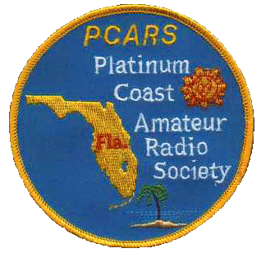

PCARS
PO Box 1004
Melbourne, FL 32902-1004

Platinum Coast ARS Donation Receipt

PCARS is a 501(c)(3) organization. IRS Federal ID #591842317

Received Of: ____________________________________________

Address: ____________________________________________

____________________________________________

Description of items:

______________________________ _________________
Signature Date

Club Officer Position:

