42nd Annual Melbourne HAMFEST Prizes

First Prize IC-718 HF Transceiver
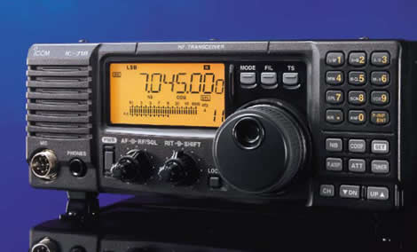
http://www.icomamerica.com/products/amateur/718/

Second Prize IC-208H Dual Band Transceiver
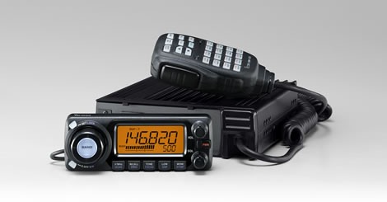
http://www.icomamerica.com/products/amateur/208h/default.asp

Third Prize IC-2200H VHF Transceiver 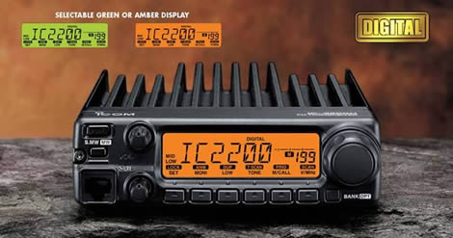
http://www.icomamerica.com/products/amateur/2200h/default.asp

Special Saturday afternoon door prize

At 3:00PM Saturday an ICOM IC-V82 VHF Handheld will be drawn as the door prize. Winner must be present to win. See it at: http://www.icomamerica.com/products/amateur/v82_u82/default.asp 