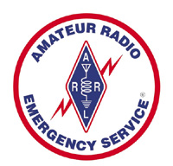

The Amateur Radio Emergency Service (ARES) consists of licensed amateurs who have voluntarily registered their qualifications and equipment for communications duty in the public service when disaster strikes. Every licensed amateur, regardless of membership in ARRL or any other local or national organization, is eligible for membership in the ARES. The only qualification, other than possession of an Amateur Radio license, is a sincere desire to serve. Because ARES is an amateur service, only amateurs are eligible for membership. The possession of emergency-powered equipment is desirable, but is not a requirement for membership.

Each year at the Melbourne Hamfest the Brevard County Emergency Coordinator (EC), Ray Kassis-N4LEM, provides equipment to make ARES photo badges for amateur radio ARES volunteers.

Visit the ARES booth near the concession stand to volunteer for ARES and obtain your photo badge.

For more information click on this link. ARRL ARES Information

