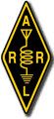 DXCC Award Checking 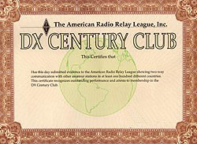

An ARRL Award checker will be available at the ARRL Booth in the West Wing near the Food Service Area.

- This service will be available on Saturday.

- Applicants must bring completed application forms required for the DXCC award.

- Where required cards must be listed on the required form or an acceptable substitute (like Excel spreadsheet) in the order prescribed for that award.

- Applicant must provide a stamped envelope addressed to the ARRL to mail the application once verified and signed by the card checker.

- For specific award information visit the ARRL Web Site Carefully read the section on Field Checking of QSL cards.

- If you have additional questions email our Hamfest email address and we will put you in touch with the award checker who will be at the hamfest.

