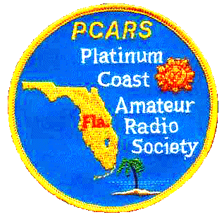 | Platinum Coast Amateur Radio Society, Inc.  Post Office Box 1004  Melbourne, Florida 32902-1004 | 

August 22, 2008 DRAFT DRAFT

To: Vendors of RF, Microwave, and Communications Components in Florida

Subject: Participation in the Platinum Coast Amateur Radio Society, Inc. (PCARS) 2008 Melbourne Hamfest

Salutations:

For the third consecutive year, the Platinum Coast Amateur Radio Society, Inc. (PCARS) is host to the state convention of the state’s membership of the American Radio Relay League, the national organization for amateur radio operators. Our “2008 Melbourne Hamfest” will have a projected 2,000 attendees over two days, October 11th and 12th, with most attending on at least Saturday. Some of the attendees are involved in RF, microwave, and various types of radio communications professionally, and might be interested in your wares.

Even though this is one of the several largest annual hamfests in Florida, the continued sponsorship by this 43 year old local non-profit club in a relatively small city has assured consistently good planning and organization, and a high degree of satisfaction by the attendees. Due to high gas prices, some of our out of state vendors are not attending this year, which has left some commercial exhibit areas untaken. For the first time, we are inviting vendors in areas most likely to be of interest to our attendees (i.e., RF, microwave, and communications components) to rent commercial booths if they think it would be advantageous. In return, we are expecting no “pushy” sales activities since this is a hobby show, and not a venue where attendees are aggressively solicited.

Jan Heise is the chairman of our 2008 Melbourne Hamfest. He has been very active in our local PCARS club and is a former president. He spends his time among his family activities, ham radio pursuits (including disaster communications), church activities, and overseas mission trips--all with the intent of making a positive difference in his retirement. Please give him a call at the numbers (also given at the bottom of the Vendor Reservation Form with other contact information-- Home: 321-956-2482; Cell: 321-223-2988) for more information.

Please note the small disclaimer in the lower right of that form. Your participation in this does not affect your standing with any of us in our employment. If you think this is a good opportunity to meet potential, new customers, then you may want to call Jan. If this is not a match, then that is also a good decision.

Thank you for your interest. Even if you choose not to exhibit, please consider attending if you like.

Best regards,

Dennis I. O’Quinn, K4CXX

President, PCARS

