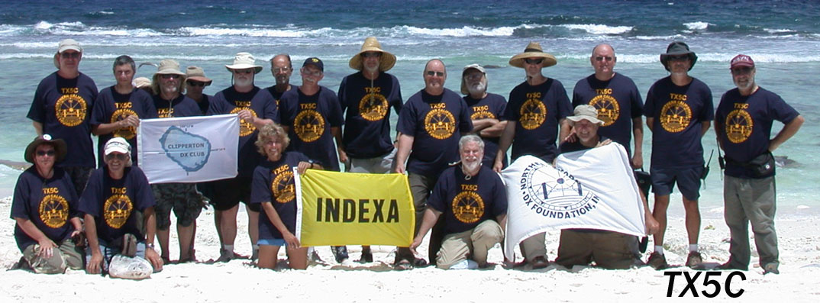
TX5C Clipperton Island DXpedition – 2008
By Bill Beyer, N2WB and Al Hernandez, K3VN
1:00-2:00PM Main Forum Area # 1
Clipperton Island is a nine-square-kilometer coral atoll in the North Pacific Ocean, southwest of Mexico and west of Costa Rica, at 10°18′N, 109°13′W. The trip to the island takes over six days by boat from San Diego, California.
Clipperton is an overseas possession of France administered by the Minister of Overseas France and has no permanent inhabitants.
Al-K3VN and Bill-N2WB were members of the TX5C team. The team made a total of 71, 794 QSO’s in 156 hours of operation under severe weather conditions including high heat and humidity.

